KITH AND KIN INTERNATIONAL COLLEGE

*7/11 Kaoli Olusanya Street, Owode Ibeshe, Ikorodu, Lagos State.*

THIRD TERM EXAMINATION 2024/2025 ACADEMIC SESSION



|  |  |  |  |  |  |
| --- | --- | --- | --- | --- | --- |
| **NAME** |  | | | | |
| **SUBJECT** | AGRICULTURAL SCIENCE | **CLASS** | **S2 2** | **DURATION** | **2 HOURS** |

**PART 1**

**INSTRUCTION: ANSWER ALL QUESTIONS**

**OBJECTIVE TEST [60 marks]**

1. Which of the following farm practices DO NOT have a significant harmful effect on the soil?

A. Crop rotation

B. Land clearing

C. Overgrazing

D. Bush burning

2. ______ and ______ are the two major causes of disease in crops

A. virus and bacteria

B. fungi and bacteria

C. pathogens and physiological factors

D. nematode and nutrient deficiency

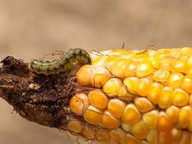

3. Maize smut disease of maize is caused by _______

A. nematode

B. bacteria

C. virus

D. fungi

4. Which of the following pairs of organisms are most active in decomposing soil organic matter?

A. Fungi and protozoa

B. Fungi and bacteria

C. Protozoa and viruses

D. Bacteria and viruses

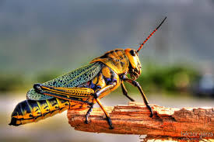

5. Economic importance of the above image include the following EXCEPT

A. it increases the cost of production

B. it is a carrier or vector of disease

C. it reduces the quality of the crops

D. it increases the quality of the crops

6. The following methods are used in controlling pest of crops EXCEPT

A. Physical method

B. Cultural method

C. Chemical method

D. Artificial method

Use the image below to answer questions **7-9**

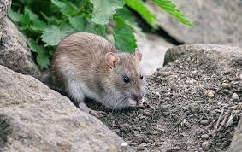

7. Which of the following is NOT used in controlling the above image?

A. Trapping with baits

B. Use of rodenticides

C. Use of predators

D. Early harvesting

8. The image is an example of ________ crop pest

A. Rodent

B. Nematode

C. Monkey

D. Insect

9. The image above attacks the following crops EXCEPT

A. Rice

B. Yam

C. Cassava

D. Vegetables

***Study the demand schedule for an agricultural commodity below and use it to answer Question 10-13.***

|  |  |
| --- | --- |
| **Price (N)** | **Quality Demanded (kg)** |
| 30 | 200 |
| 20 | 240 |

10. Calculate the percentage change in quantity of commodity demanded.

A. 10%

B. 20%

C. 30%

D. 40%

11. Calculate the percentage change in price for the commodity.

A. 50.0%

B. 40.0%

C. 33.3%

D. 23.3%

12. Find the elasticity of demand for the commodity.

A. 0.9

B. 0.8

C. 0.6

D. 0.3

13. Tsetse flies are of economic importance in livestock production because they transmit

A. Coccidia.

B. Trypanosome

C. Brucella

D. Mycobacterium

14. What fishing gear is illustrated below?

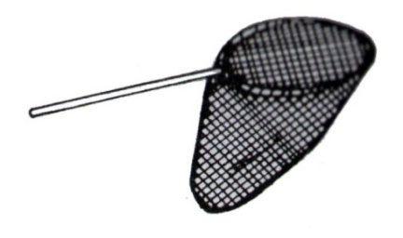

A. Cast net

B. Lift net

C. Scoop net

D. Trawl net

15. A young female cattle which has never calved is known as

A. bullock.

B. steer.

C. yearling.

D. heifer.

**If T represents the gene for tallness while t represents dwarfness, use the information to answer questions 16 and 17.  
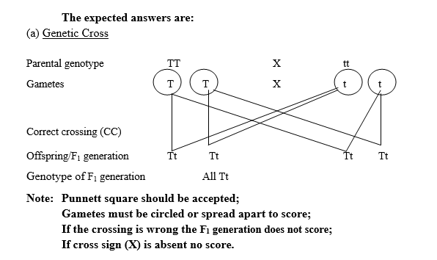**

16. When a tall (TT) crop is crossed with a dwarf (tt) crop, the resultant crops will be

A. 100% dwarf.

B. 100% tall.

C. 50% taIl and 50% dwarf.

D. 75% tall and 25% dwarf.

17. The genotypic ratio of the second filial generation will be

A. 3:1

B. 1:2:1

C. 2:2

D. 4:0

18. The average seed rate for maize is 25kg per hectare. Allowing for seed wastage of 5%, how many kilograms of seeds would be required in planting 10 hectares of farm land?

A. 237kg

B. 238kg

C. 250kg

D. 255kg

19. Which of the following will retain the greatest amount of water?

A. Sand

B.Loam

C. Clay

D. Silt

20. Airsacs are present in

A. poultry

B. goat

C. cattle

D. sheep

21. The gestation period in days of a sow is

A. 30

B. 114

C. 120

D. 150

22. The castrated male cattle is referred to as

A. bull

B. heifer

C. wether

D. steer

23. The amount of livestock feed needed to prevent either an increase or decrease in live weight of an animal is referred to as

A. breeding ration

B. weaners ration

C. maintenance ration

D. balance ration

24. Which of the combinations is necessary for disease to occur in plant?

A. Pathogen, host and environment

B. Disease, environment and virus

C. Environment, vector and disease

D. Host, pathogen and vector

25. Common pasture grasses include the following EXCEPT

A. Guinea grass

B, elephant grass

C.carpet grass

D. imperata cylindrical

26. Which of the following is pasture grass?

A. Stylosanthes gracilis

B. Centrosema pubescen

C. Pueraria phaseoloides

D. Cynodon dactylon

27. Cultural methods of controlling pests include the following except

A. Timely planting

B. crop rotation

C. mulching

D. frequency of weeding

28. Which of the following is the primary function of the gizzard?

A. Storage of food before digestion

B. Fermentation of injested

C. Absorption of digested food

D. Grinding of ingested food into smaller particles

29. Gestation period is defined as the time

A. of fusion of the sperm and the egg

B. between conception and parturition

C. of release of egg from the ovary

D. of the birth of the young animal

30. The act of mating in cattle is known as

A. service

B. treading

C. laying

D. tupping

31. The hormone generally called pregnancy hormone is

A. testosterone

B. oestrogen

C. progesterone

D. relaxin

32. New born animals should be fed with colostrums because

A. it is easily digested

B. contains food nutrients essential for the survival of the young animal

C. contains antibodies protecting them against diseases

D. is the first milk produced before birth

33. Which of the following breeds of cattle is an imported breed?

A. keteku

B. N’dama

C. white Fulani

D. red bororo

34. High fibre and low energy feeds are classified as

A. basal feeds

B. proteins

C. concentrates

D. roughages

35. The proportion of the different types of feed given to an animal daily is known as

A. concentrate

B. additive

C. ration

D. supplement

36. The main component of egg shell is

A. vitamin

B. calcium

C. iron

D. manganese

37. The device which helps to stabilize heat in an incubator is the

A. thermometer.

B. hygrometer.

C. barometer.

D. thermostat.

38. Marketing agents include the following EXCEPT

A. Producer

B. Cooperative society.

C. Wholesaler.

D. Market women.

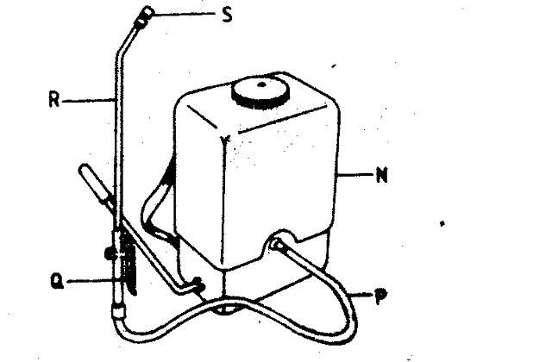

39. Which of the labeled parts is referred to as the handle?

A S  
B. N

C. P

D. Q

40. The general method of maintaining the above image include the following EXCEPT

A. Wash and dry after use.

B. Keep in a cool, dry place

C. grease the part labeled **N** very well before and after use.

D. always check the nozzle before and after use.

41. Which type of loan should a farmer obtain to start an oil palm plantation?

A. Short-term loan

B. Long-term loan

C. Non-institutional loan

D. Operational loan

42. Calculate the annual depreciation of a farm house using the following data:  
(i) The initial cost of farm house = #100,000.00  
(ii) Expected life span of farm house = 100 years  
(iii) Estimated salvage value of farm house = #25,000.00

A. #750.0O

B. #725.OO

C. #720.OO

D. #700.OO

43. The most important factor which determines the demand for cowpea by consumers is the

A. income of consumers.

B. price of cowpea.

C. supply of cowpea.

D- taste of consumers.

44.Land in agricultural business is a durable asset because

A.its value is realized over several years.

B. It is more valuable than labour.

C.It can be expanded by reclamation.

D. It isafreegiftofnature.

45. A cowpea farmer obtained a loan of #50,000.00 from his co-operative society at an interest rate of 5%. Calculate the interest to be paid on the borrowed capital after one year.  
A. #2,500.00  
B. #5,000.00  
C. #7,500.O0  
D. #10,000.00

46. 1f the recommended spacing for a tree crop is 2.5m by 4.Om, determine the number of seedlings  
required to plant a 2-hectare farmland.

A. 1,000

B. 2,000

C. 10,000

D. 20,000

47. In animal production, newly-born rabbits are called

A. bunnies.

B. kids.

C. poults.

D. lambs.

48. The weight of a sheep increased from 25kg to 45kg in two months. If the total consumption during the period was 60kg, determine the feed conversion ratio.

A. 1:1

B. 1:2

C 3:1

D. 4:1

**The data for feed consumption and weight gain of four farm animals labelled P, Q, R and S are shown below:**

P - 50 kg feed consumed and 20 kg weight gained

Q - 90 kg feed consumed and 30 kg weight gained

R - 100 kg feed consumed and 25 kg weight gained

S - 150 kg feed consumed and 30 kg weight gained

**Use the data to answer questions 49 and 50.**

49. Which animal is the most efficient feed converter?

**A. P**

**B. Q**

**C.R**

**D. S**

50. The feed conversion efficiency of the poorest weight gainer is

A. 0.40  
B. 0.33

C. 0.25  
D. 0.20

**PART B - ESSAY**

**[40 Marks]**

INSTRUCTIONS: There are six questions in this part. Answer any four questions.

All questions carry equal marks.

1. a. Differentiate between demand and supply. 2marks

b. Give four factors affecting demand. 2 marks

c. Briefly explain three types of price elasticity of demand. 3 marks

d. With the aid of demand curve, illustrate the data below. 3marks

|  |  |  |
| --- | --- | --- |
| S/N | PRICE (#) | QUANTITY DEMANDED (KG) |
| 1 | 100 | 10 |
| 2 | 80 | 20 |
| 3 | 60 | 30 |
| 4 | 40 | 40 |
| 5 | 20 | 50 |

2a. i. Define farm records and farm accounts. 2marks

ii. Give five importance of keeping such records. 5 marks

b. A commercial farmer bought a second hand harvester for #100,000 in year 2000 and sold

it in year 2010 for #30,000. Calculate the

i. Salvage value

ii. Total depreciation

iii. Annual depreciation 3 marks

3a. Complete and copy the table below based on Mendel’s Law of Independent Assortment of Genes

(Dihybrid inheritance). Use the following information: T Tallness, C Coloured, t Shortness

and c White. 6marks

|  |  |  |  |  |
| --- | --- | --- | --- | --- |
|  | TC | Tc | Tc | TC |
| TC | TTCC |  |  |  |
| Tc |  | Ttcc |  |  |
| tC |  |  |  | ttCc |
| Tc |  |  | ttcC |  |

b. Calculate the percentage of plants in (a) above that are. 4marks

i. Tall coloured

ii. Tall white

iii. Dwarf coloured

iv. Dwarf white

4. a. Briefly explain the following genetic terms marks

i. Homozygous

ii. Back cross

iii. Dominance

iv Hereditary. 4 marks

b. State the law of demand and six basic assumptions as it relates to agricultural products. 6 marks

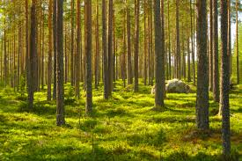

5. Use the image above to answer questions that follow

a. How are forests useful to us? State eight 4marks

b. Differentiate between the following terms;

i. Forest and forestry 2marks

ii. Silviculture and selective exploration 2marks

c. highlight eight common forest trees 2marks

6. a. What do you understand by crop improvement? 2marks

b. State five aims of crop improvement. 5marks

c. Briefly explain the following processes of crop improvement

i. Introduction

ii Selection

iii Breeding 3marks